# Research on the Development Status of Multimodal Non-Invasive Brain-Computer Interfaces

## Abstract This paper investigates the current technological advancements in multimodal non-invasive brain-computer interfaces (BCIs) and explores their potential applications in medical rehabilitation, neural regulation, and intelligent interaction. The study systematically reviews the technological progress in signal acquisition and preprocessing, decoding algorithms and classification models, and multimodal feedback mechanisms. It also analyzes the core challenges faced by the technology, including insufficient signal reliability, limited real-time performance, and privacy security risks. Furthermore, the paper proposes recommendations for the future development of multimodal non-invasive BCIs, aiming to provide insights for the innovation of human-computer interaction paradigms.

**Keywords** Multimodal Non-Invasive BCI, Signal Acquisition, Decoding Algorithms, Multimodal Feedback, Edge Computing

## 1 Introduction

With the rapid advancement of technology, brain-computer interfaces (BCIs) have become one of the cutting-edge fields in science and technology. Non-invasive BCIs, characterized by their non-invasive nature and low risk, have emerged as a research hotspot in the field of neural engineering. Breakthroughs in multimodal signal (visual, tactile, auditory) fusion technology have demonstrated the broad prospects of multimodal non-invasive BCIs in medical rehabilitation, industrial collaboration, and smart living. A deep understanding of the development status of multimodal non-invasive BCIs is crucial for grasping technological trends, meeting market demands, and promoting industrial upgrading. For enterprises and R&D teams, understanding the current technological landscape and market applications can help identify innovation directions and better meet consumer needs. For policymakers, insights into the current state and future trends of technological development can facilitate the formulation of reasonable policies and standards, thereby fostering the healthy growth of the industry.

## 2 Development Status of Multimodal Non-Invasive BCIs

## *2.1 Signal Acquisition and Preprocessing Technology*

Signal acquisition and preprocessing are the first steps in the operation of a BCI, and their importance in the overall workflow is self-evident. Multimodal non-invasive BCIs have achieved significant breakthroughs in this area: wireless multi-channel devices such as OpenBCI's Ganglion[1] enable real-time EEG signal acquisition through high-density electrode arrays and support seamless integration with multimodal extension modules such as fNIRS and eye-tracking. Advances in flexible electronics have further optimized the wearability of these devices. For instance, graphene-based flexible electrodes (e.g., KAIST's NeuroFlex) can conform to the curvature of the scalp. In contrast, although invasive technologies can achieve microvolt-level high-precision signal capture through flexible electrodes, their reliance on surgical implantation limits their widespread clinical adoption.

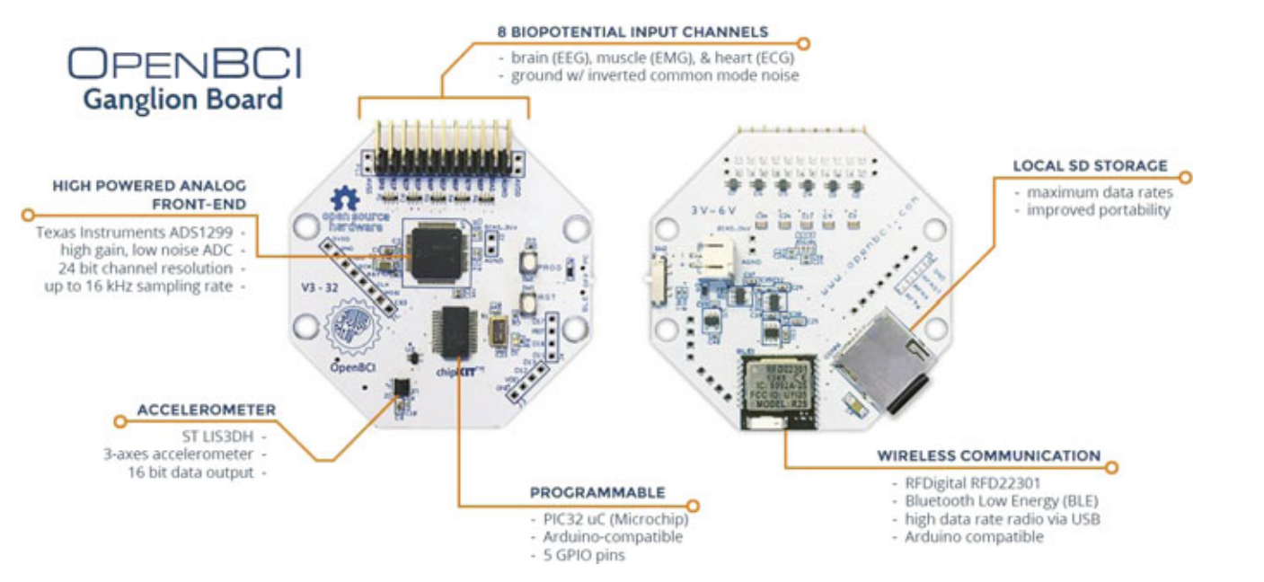

**Fig.1** OpenBCI’s Ganglion Board

## *2.2 Decoding Algorithms and Classification Models*

In the field of multimodal non-invasive BCIs, research on decoding algorithms and classification models has seen a synergistic evolution of traditional machine learning and deep learning. Among traditional methods, support vector machines (SVMs) maintain an advantage in lightweight tasks due to their high real-time performance and robustness. However, when dealing with the complexity of multimodal signals (e.g., EEG-fNIRS fusion data), lightweight convolutional networks such as EEGNet, which employ local feature extraction and parameter compression, have shown greater potential in tasks like emotion recognition. Nevertheless, their computational demands and real-time performance are still constrained by the capabilities of edge devices[2].

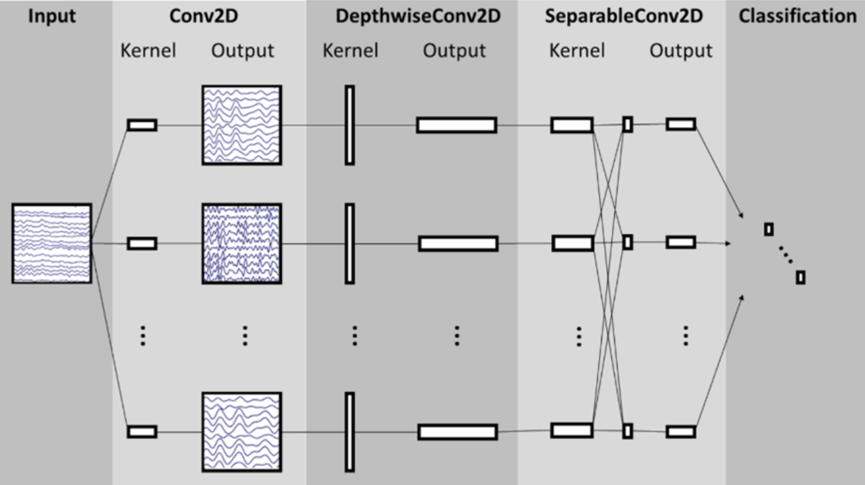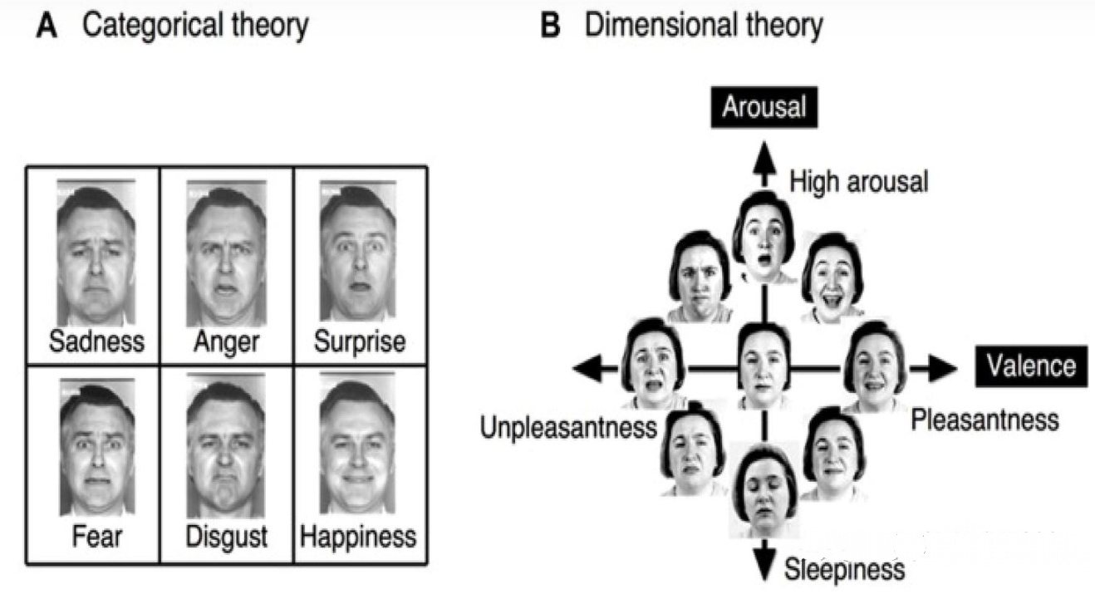

**Fig.2** EEGNet **Fig.3** EEGNet in Emotion Recognition Tasks[3]

## *2.3 Multimodal Feedback Mechanisms*

Multimodal non-invasive BCIs are significantly enhancing user experience through the synergistic integration of visual, tactile, and auditory feedback. Visual feedback, as the core interaction method, strengthens users' perception and confidence in control signals through real-time robotic posture mirroring (e.g., virtual arm motion simulation). The deep integration of tactile and auditory feedback further optimizes closed-loop interaction: tactile vibration feedback encodes operational states through intensity and frequency, while synchronized auditory cues (e.g., voice or sound effects) assist in rapid system response recognition, reducing cognitive load. For example, in virtual reality (VR)-driven stroke rehabilitation training, patients can intuitively perceive limb movement trajectories, receive tactile cues to correct motion deviations, and benefit from voice encouragement through a "visual-tactile-auditory" multimodal feedback system, significantly shortening their adaptation period[5][6]. In the future, the combination of adaptive feedback algorithms (e.g., dynamic modal weight adjustment based on user state) and flexible wearable devices will further advance the practical application of non-invasive BCIs in medical, educational, and entertainment fields.

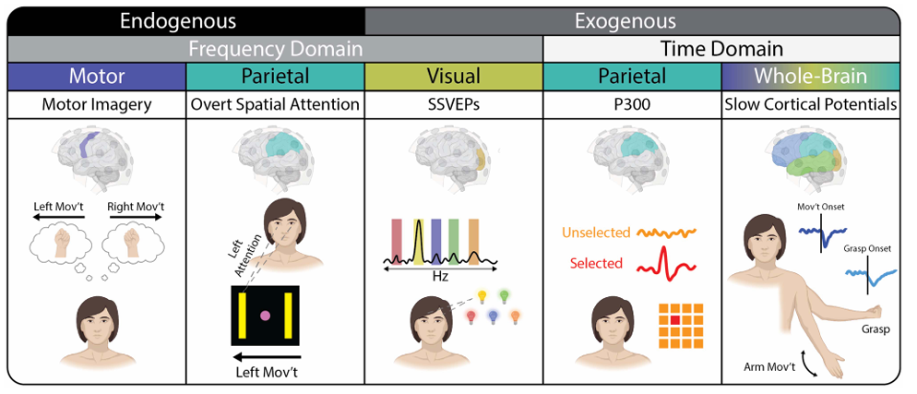

**Fig.4** Overview of neural signals used for noninvasive brain-computer interface control[6]

## *2.4 Technical Bottlenecks and Challenges*

Despite technological breakthroughs, multimodal non-invasive BCIs still face multiple technical bottlenecks: individual physiological differences and myoelectric artifacts significantly reduce signal reliability, while the cross-user generalization capability of existing models heavily relies on time-consuming calibration. Additionally, the computational latency of complex algorithms on edge devices struggles to meet the real-time control demands of industrial scenarios. Furthermore, the challenge of time synchronization in multimodal signals (e.g., the sampling frequency difference between EEG at 1kHz and fNIRS at 10Hz) necessitates high-cost hardware (e.g., Intel SyncCore chips), and motion artifacts and environmental noise (e.g., electromagnetic interference) can reduce the signal-to-noise ratio to below 5dB, exceeding the processing capacity of traditional filtering algorithms. Balancing hardware cost, algorithmic efficiency, and user adaptability remains a challenge that requires further breakthroughs through lightweight design and interdisciplinary collaboration. Moreover, the neural data collected by BCIs contain sensitive information, posing privacy leakage risks, and the application areas of BCI technology also raise ethical concerns.

## *2.5 Market Scale*

The global BCI market is estimated to reach $2.44 billion in 2024 and is expected to exceed $6 billion by 2028. Although China started later in the BCI field, its market has grown rapidly. In 2022, the market size of BCIs in China was approximately RMB 1 billion, and it is projected to reach $3.3 billion by 2027, with an average annual compound growth rate of 21%, demonstrating the immense potential of China's BCI market. The healthcare sector is one of the most commercially promising application areas for BCI technology, accounting for 61.59% of the market share[7]. In the future, as more BCI products are launched and clinical applications expand, the market size of BCI technology is expected to grow further.

## 3 Recommendations for the Development of Multimodal Non-Invasive BCIs

## *3.1 Technological Innovation and Hardware Optimization*

Lightweight and low-power hardware design is the key to advancing the practical application of multimodal non-invasive BCIs. By developing flexible electronic systems integrated with multimodal sensors, devices can simultaneously acquire EEG, fNIRS, and electrodermal signals, reducing power consumption and minimizing wear volume. Additionally, exploring energy harvesting technologies such as biothermal-electric conversion can extend device battery life to over 72 hours, meeting the requirements for all-day monitoring. At the algorithmic level, adaptive fusion technologies combined with federated learning and transfer learning frameworks can shorten personalized calibration times. The development of lightweight Transformer variants can achieve low-latency, high-precision multimodal signal decoding on edge devices, meeting the real-time demands of both medical and consumer-grade applications.

## *3.2 Optimizing User Experience*

Wearability and natural interaction are critical to enhancing user acceptance. The use of breathable materials and modular designs can reduce wearing pressure, while quick-detach designs can simplify the user experience. On the interaction front, the introduction of multimodal feedback mechanisms, combining visual, tactile, and auditory cues, can improve operational accuracy and enhance immersive experiences. For example, in VR rehabilitation training, patients can intuitively perceive motion errors and quickly adjust through real-time limb motion mapping and tactile vibration cues, thereby shortening the adaptation period.

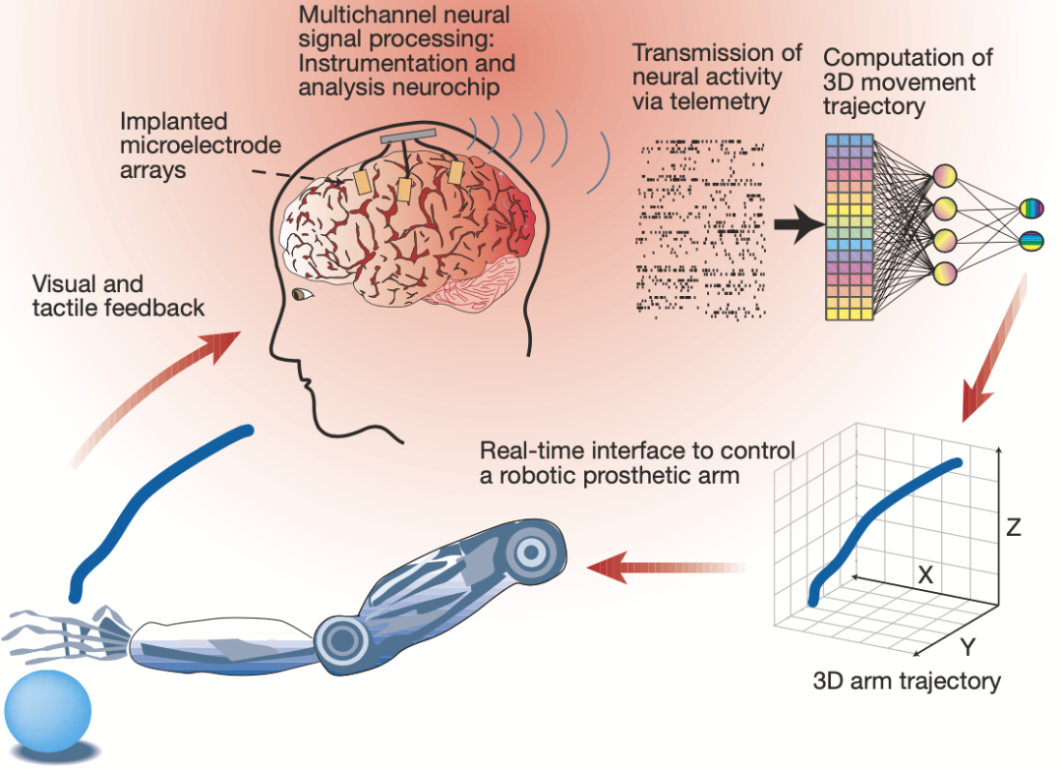

**Fig.5** Multimodal feedback

## *3.3 Emphasizing Privacy Protection and Data Security*

Focusing on privacy protection and data security is the cornerstone of the long-term development of BCI technology. In the current digital era, BCI devices often need to collect and process large amounts of personal data, including sensitive information such as health and location data. Therefore, developers must establish strict data protection mechanisms to ensure that all data collection, transmission, and processing comply with relevant laws and regulations. Additionally, enhancing users' control over their own data management can increase their confidence in using these devices, thereby improving user trust and product appeal.

## 4 Reflections, Summary and Outlook

Hardware advances improve signal acquisition and wearability, yet reliability issues persist, requiring hardware-algorithm co-optimization. Deep learning excels in multimodal analysis but faces real-time edge device limits, pushing lightweight design and hardware acceleration as solutions. Multimodal feedback enhances interaction, but high-cost synchronization needs low-cost alternatives. Security is critical, with federated learning and differential privacy offering partial safeguards. Interdisciplinary collaboration and open ecosystems are key to transitioning BCIs from labs to daily use.

Multimodal non-invasive BCIs are transitioning from laboratory prototypes to large-scale applications, but their development must overcome bottlenecks in signal fusion, computational efficiency, and user adaptability. In the future, with the maturation of flexible electronics, edge AI, and privacy computing technologies, multimodal non-invasive BCIs are expected to achieve deeper "brain-machine-environment" collaboration in medical, educational, and entertainment fields, reshaping human-computer interaction paradigms.

## References

1. Samson, V. R., et al. “Electroencephalogram-based openbci devices for disabled people.” Lecture Notes in Electrical Engineering, 7 Sept. 2017, pp. 229–238, <https://doi.org/10.1007/978-981-10-4280-5_24>.
2. Asgher, Umer, et al. “Editorial: Advances in artificial intelligence (AI) in Brain Computer Interface (BCI) and Industry 4.0 for Human Machine Interaction (HMI).” Frontiers in Human Neuroscience, vol. 17, 5 Dec. 2023, <https://doi.org/10.3389/fnhum.2023.1320536>.
3. Rahman, Md. Mustafizur, et al. “Recognition of human emotions using EEG Signals: A Review.” Computers in Biology and Medicine, vol. 136, Sept. 2021, p. 104696, <https://doi.org/10.1016/j.compbiomed.2021.104696>.
4. StartUs Insights. “Discover 5 Top Brain-Computer Interface (BCI) Solutions.” StartUs Insights, 8 Dec. 2021, <www.startus-insights.com/innovators-guide/brain-computer-interface/>.
5. Tang, Wenzhe, et al. “Emerging themes and future directions in Neurodesign and human-computer interaction: A systematic review.” International Journal of Human–Computer Interaction, vol. 41, no. 2, 17 June 2024, pp. 1652–1673, <https://doi.org/10.1080/10447318.2024.2362486>.
6. Edelman, Bradley J., et al. “Non-invasive brain-computer interfaces: State of the art and trends.” IEEE Reviews in Biomedical Engineering, vol. 18, 2025, pp. 26–49, <https://doi.org/10.1109/rbme.2024.3449790>.
7. “Brain-Computer Interface Market Size, Share, Trends & Insights Report, 2035.” Brain-Computer Interface Market Size, Share, Trends & Insights Report, 2035, 27 Jan. 2025, <www.rootsanalysis.com/brain-computer-interface-market>.